33. Prolog Program – Number of Vowels
Name:P.Gayathri
Reg.No:192424324

Aim
To write and execute a Prolog program to find the total number of vowels in a given word or list of characters using facts, rules, recursion, and logical queries.
Algorithm
- Start the Prolog program.
- Define the five vowels: a, e, i, o, and u.
- Define a predicate count_vowels/2.
- If the input list is empty, return 0.
- Take the first character from the list.
- Check whether the character is a vowel.
- If it is a vowel, increase the count by 1.
- If it is not a vowel, continue without increasing the count.
- Recursively process the remaining characters.
- Display the final vowel count.
- Stop the program.

Code:
% Vowel Facts

vowel(a).
vowel(e).
vowel(i).
vowel(o).
vowel(u).

% Count Vowels in a List

count_vowels([], 0).

count_vowels([H|T], Count) :-
vowel(H),
count_vowels(T, C),
Count is C + 1.

count_vowels([H|T], Count) :-
\+ vowel(H),
count_vowels(T, Count).
INPUT:
?- count_vowels([a,p,p,l,e], Count).
OUTPUT:
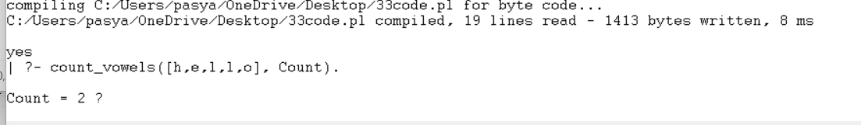
Result:
Thus, the Prolog program was successfully executed to count the number of vowels in different words. The program correctly identifies a, e, i, o, and u as vowels and calculates their total using recursive rules.

